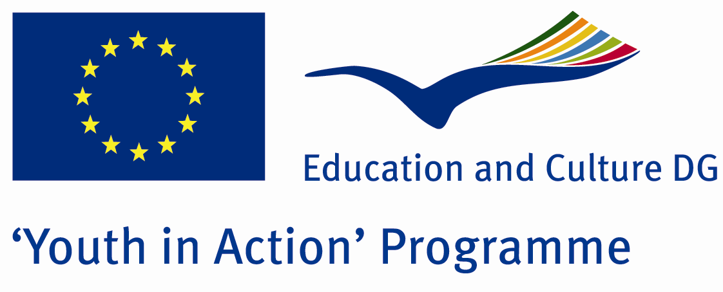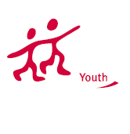

Change / Exchange office



ACTION 1.1 – Youth Exchange

18-25th July , 2012

Artvin, TURKEY

Please contact directly to;
groupisbut@gmail.com

Project Summary;

The Money was invented by Historic Lydia country and from beginnig of invention up to now, it has been a symbol of strength and richnes.During the eras, the Money was seen us in dffrent situations.Some countries showed their cultures in their Money, some of them showed their heroes.Sometimes, countries tried to give their ideological learnings to the world with their own money.To sum up, money is sometimes a culture, sometimes is a teacher and sometimes is a vehicle for dirty activities.It is not important what happened.money is important and valuable but in this Project we dont talk about its value (as price).We interest in its cultural value if you want to join this project, please contact us.

Project Title; Change/Exchange Office

Date and Venue ; 18-25th July, 2012 Artvin, Turkey.

Target Group ; Municipalities, City Councils and Non-Governmental organizations,
youth groups,culture and art groups,e.t.c

Participants ; 5 people from each country (over 18 -25 ). Totally 8 countries.

Conditions ; Accommodation, board and programme costs will be financed through European Commission Youth in Action Programme. Travel costs will be reimbursed in 70% (APEX Tarrifs). Organizations from all 27 EU member countries plus Liechtenstein , Norway and Iceland are eligible to take part.

Working language: English

Organizer; Group İsbut

How to apply: If you are interested, please send your Part III forms to
by e-mail please please (in word file). Scan Part3 format is enough for application. (Fulfilled Part III which you can find in the attachment, of course signed and stamped) ..

Deadline for application; until 10th October 2011.

If you have any questions you may contact with:
groupisbut@gmail.com

